ASSEMBLY INSTRUCTIONS
stackable and Connoiseur
series corner units

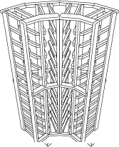

Assembly starts by putting together 4 individual columns with the frames provided.

- Using front sides ‘A’ and rear sides ‘B’ (refer to frames diagram), layout the outside columns, being sure that angled edges are both on the same side.
- Frame ‘A’ is situated at non-beveled horizontal bottle supports and air nailed through the vertical supports with 18 gauge- 1.5” brads or staples.
- Frame ‘B’ is situated at shorter horizontal bottle supports, is pre-drilled at 1/16” and attached with screws provided.
- Repeat steps 1-3 for center sections with ‘C’ and ‘D’ frames
- With the 2 center columns complete, attach them together, pre-drilling with a 1/16” bit, under front frames, through the front vertical supports, with 3 screws provided.
- Repeat, attaching side sections to completed center section.
- Screws may be installed on rear frames by pre-drilling with countersink bit, through angled frame sections.



